Full Name: Nthakgeng Mosana
Student Number: ST10495862
Group: 1
Date: 2026/09/17

PART 2 Screenshots
Figure 1:pawshearts-index.html(iPhone SE)
Figure 2: pawshearts-index.html(iPhone 16 Pro Max)
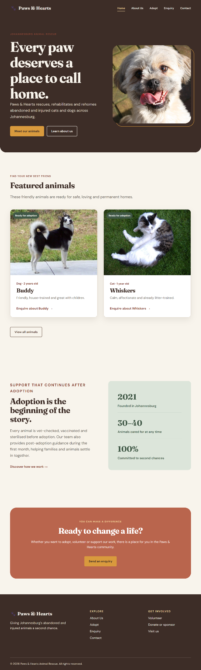
Figure 3: pawshearts-index.html(iPad Pro 13)
Figure 4: pawshearts-about.html(iPhone SE)
Figure 5: pawshearts-about.html(iPhone 16 Pro Max)
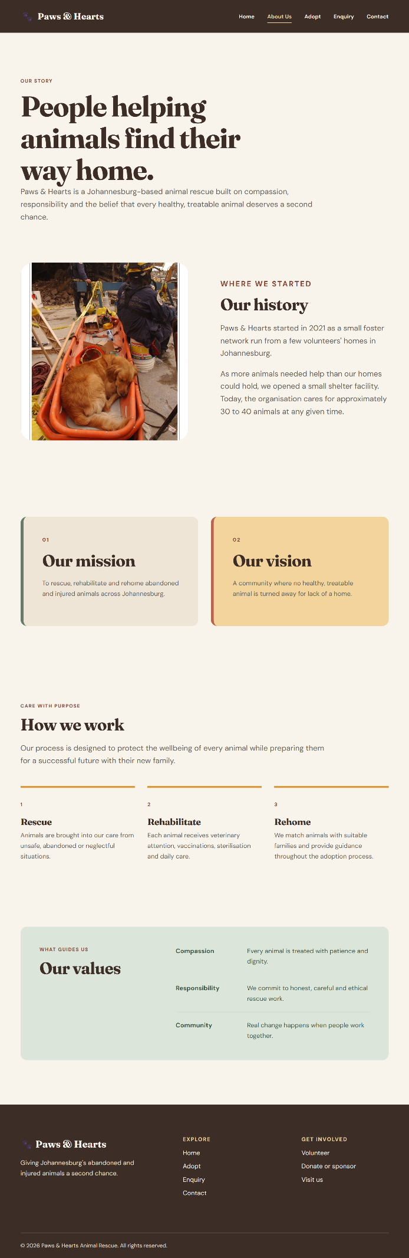
Figure 6: pawshearts-about.html(iPad Pro 13)
Figure 7: pawshearts-adopt.html(iPhone SE)
Figure 8: pawshearts-adopt.html(iPhone 16 Pro Max)
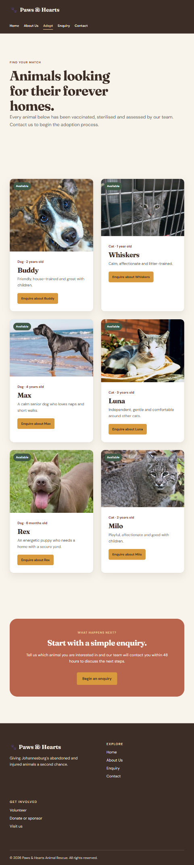
Figure 9: pawshearts-about.html(iPad Pro 13)
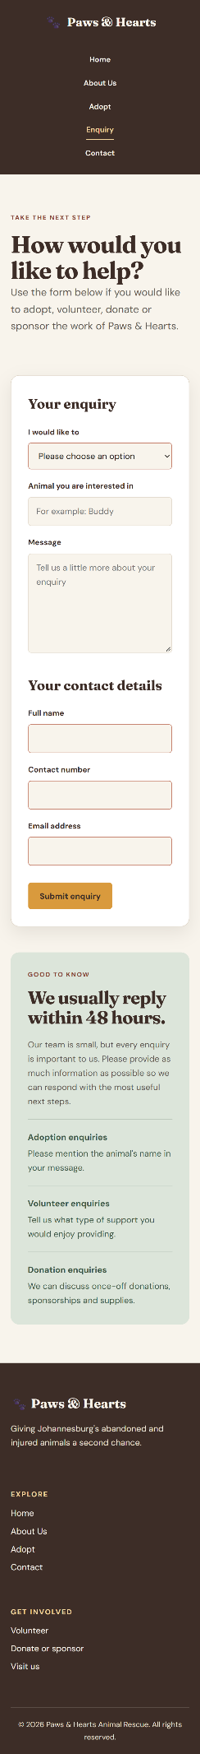
Figure 10:pawshearts-enquiry.html(iPhone SE)
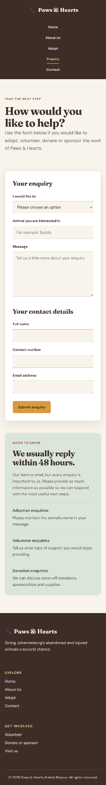
Figure 11: pawshearts-enquiry.html(iPhone 16 Pro Max)
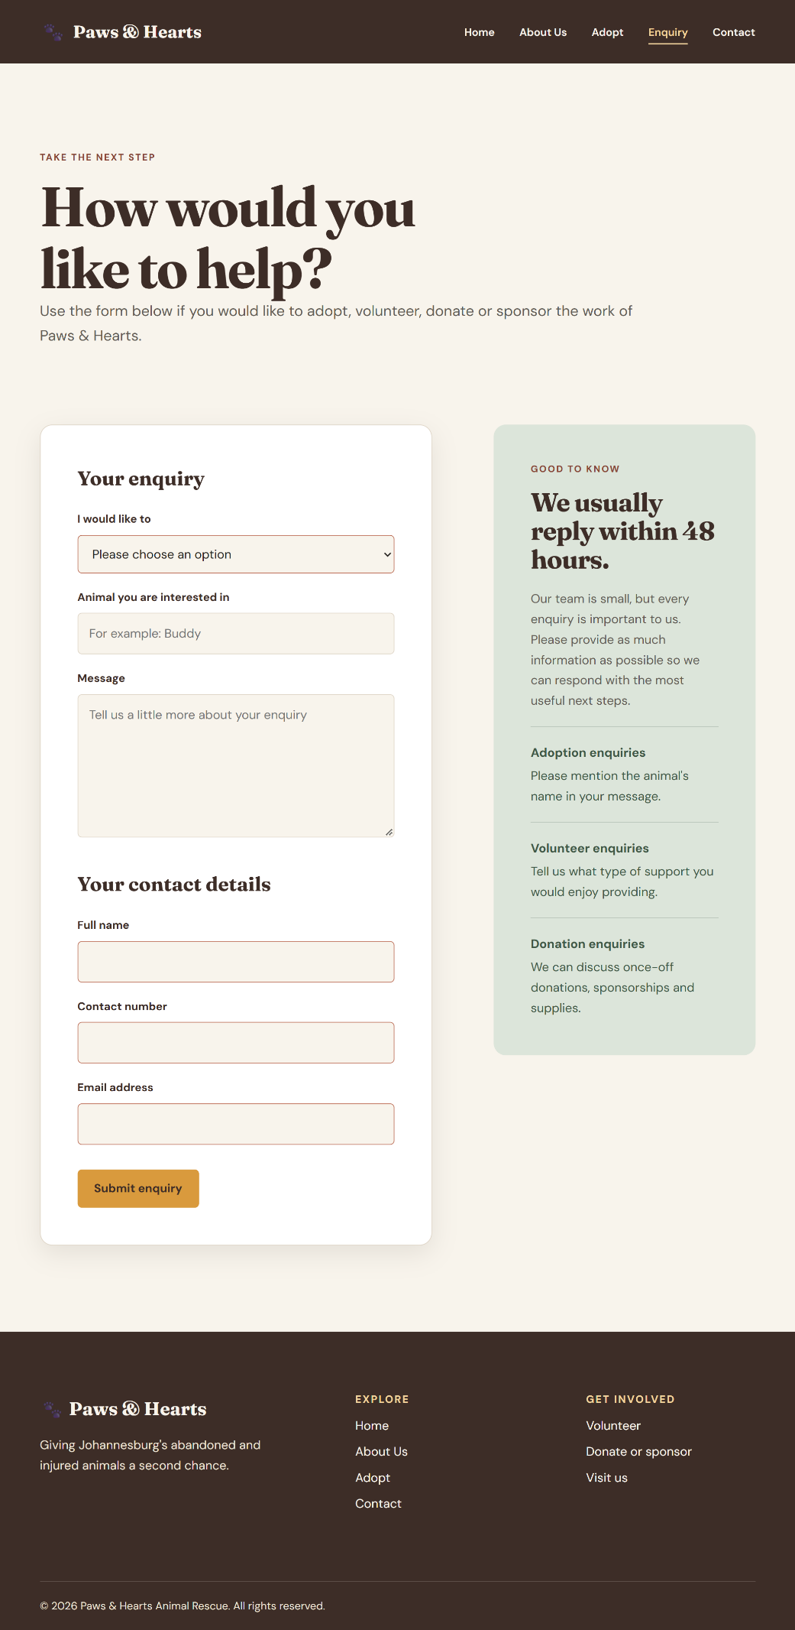
Figure 12:pawshearts-enquiry.html(iPad Pro 13)
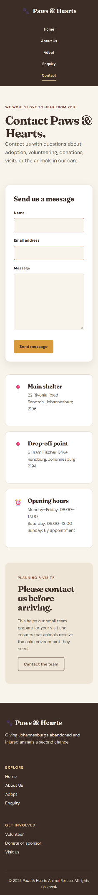
Figure 13:pawshearts-contact.html(iPhone SE)
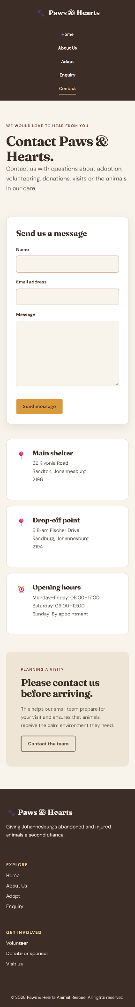
Figure 14: pawshearts-contact.html(iPhone 16 Pro Max)
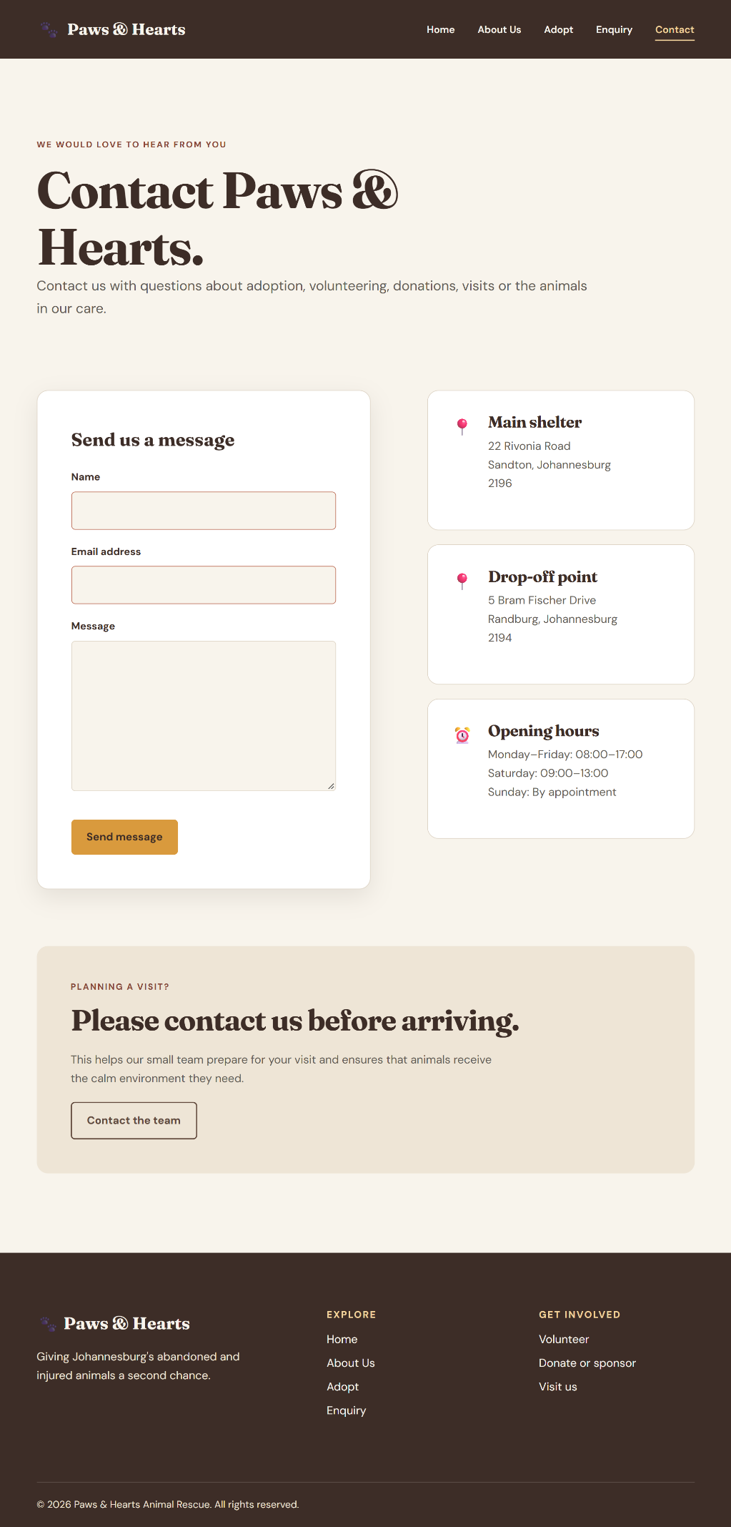
Figure 15: pawshearts-contact.html(iPad Pro 13)
GitHub

https://github.com/Mosana-NS1/pawshearts

